System Design


There you go, on the roll..

Scalability
--- Scaling of servers ---

Intro
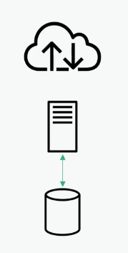
- Having web server and my Database in the same server is fine but, suddenly getting large/hard hits in my database consumes my server capability to serve the requests -> to avoid this problem we’re using a separate server for HTTP requests & separate one for DB.
Vertical scaling | Using a bigger machine
Horizontal scaling | Using more machines

- Horizontal scaling works efficiently only if the servers are stateless.
  - Stateless – The subsequent requests shouldn’t depened on something stored on that server in which the previous request has been served.

Failover servers
Primary & Secondary Servers
Cold standby :- Periodic Backup of data
- Taking too much time to backup the data to another host and a compulsory downtime occurs.
Warm standby :- Replicates the backup data
- Sec DB host replicates the primary DB (keeps itself warm) on timely basis to get into production when required(available with necessary data)
Hot standby :- Replicating on real time
- Backup already updated and live. ready to get into production at any time.
Multiprimary :-
- simultaneously read and write on both the DB servers

Sharding: Horizontal partitioning of DBs

Shard - DB is divided into subsets row wise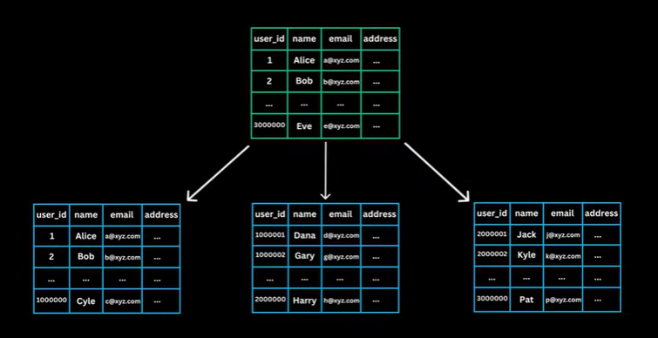
– each shard contains a subset of DB rows - distribute the load from one DB to serveral DBs.
Each one of the shards will have a primary server & secondary servers(3 servers) for high availability.
- Each shard can be placed in diff zone/region to avoid catastrophic failures.
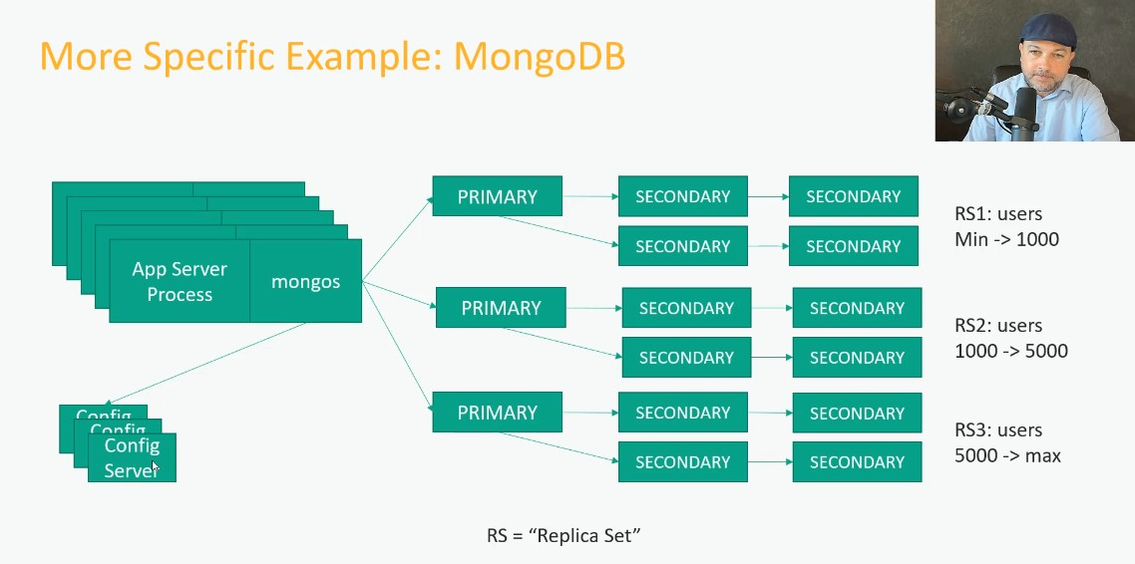

Cassandra
- Serveral nodes connected with each other – each node has all the information by sharing information among themselves – so, any node can act as primary node serving the API.
- Tradeoff here: writing the data into one node and reading it back takes time if writing & reading process done on different nodes(the delay’s because, it takes time for the written data to reach all the nodes).

Sharded DBs – NoSQL DBs

Denormalizing
- Duplicating more than one DB into a single DB(combining all the data together) to avoid multiple retrievals(retrieval from each DB) to improve the performance.
- Drawbacks:
  - Duplicated data – occupies more space
  - Updating data is hard
    - Y ? – while updating the data, it has to go through all the rows reservation ID/ customer ID(not using the primary index as used in indiviudal tables) to update the data – High time consuming process.
RDB best suits Normalized DB
NRDB(NoSQL) – Denormalized DB

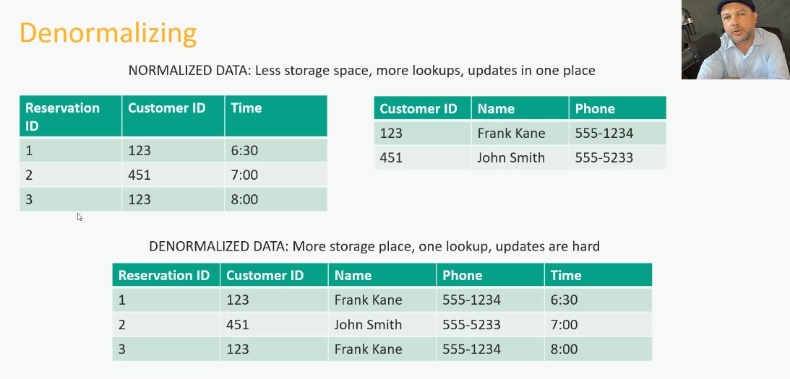

Data lake
- Putting a large amt of raw data(unstructured) in S3
  - Imparting Amazon Glue in the data lake – structures the data
  - Amazon Athena & Amazon redshift can be used to query data from S3 data lake.
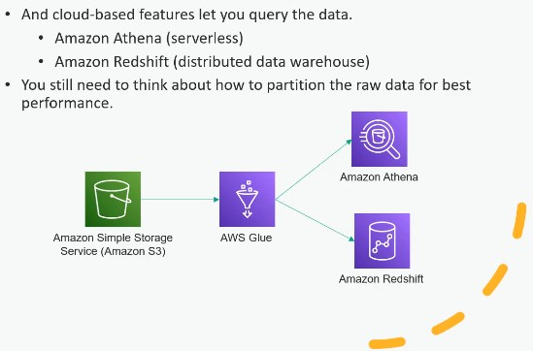

- Paritioning – helps to optimize the entire process
  - Eg: partitioning the log files by day/week helps to look for logs by days easily..

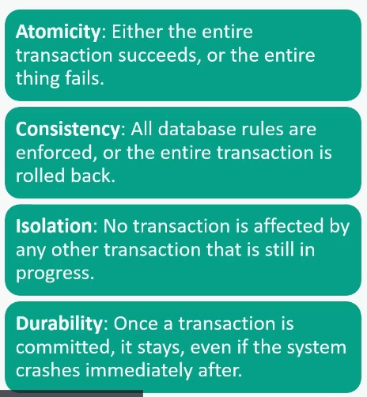
ACID compliance
Atomicity – entire transaction should succeed or fail – we don’t what transaction to be done partially(half data written leads to error)
Consistency – consistently applying rules – failing the rule rolls back the transaction.
Isolation – 2 transactions occurring at the same time shouldn’t interfere each other – Data being written by 1 transaction shouldn’t be modified by another transaction while in progress
Durability – data stored properly shouldn’t be disturbed by shutdown/immediate crash.

- Consistency[ Outside ACID compliance ] - refers to capability to read the data instantly after being written.

CAP Theorem
- Consistency, Availability, Partition-tolerance[Scalability]
  - Choosing 2 constraints among the 3, we’ve to tradeoff 1 constraint for atleast a fraction of second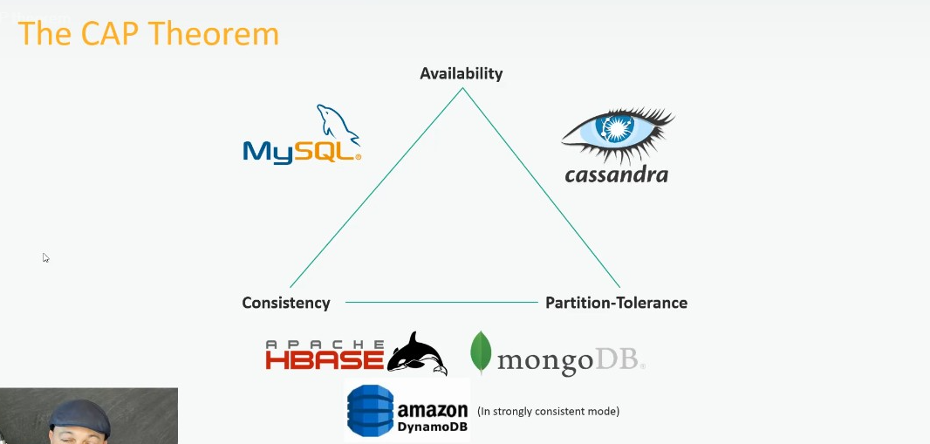

Caching
- Storing & retrieving the data in memory rather than hitting the disk everytime
  - Which is very effective for reads> writes
  - Servers hashes/maps the Key[request for a database call] to a Value[Caching host - server] for easy identification
- Horizontally scaled cache servers which are closer to the application server rather than DB performs well.
- Data expiration: Have to consider how long the data should stay in cache
- Hotspot
  - Cache should be intelligent enough to manage which data’s been requested majorly and replicate that data to serve it for major no. of requests.
- Cold cache/ Cold-start of cache
  - While starting the cache after refresh, thousands of requests coming to cache are routed to DB -> Direct hit in DB -> System fail/crash.
  - Solution: warm up the cache before getting it to the real world environment.
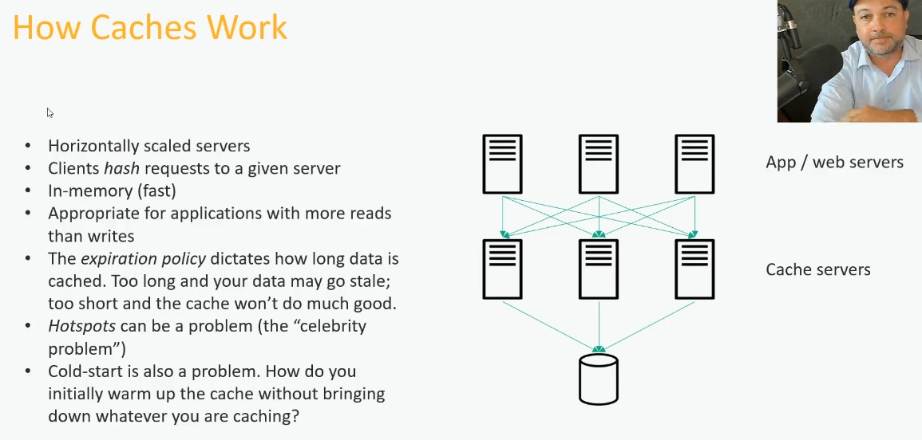
    - Simulating requests to DB, starts to fill up the cache with data[Cache Warm UP]

Eviction policies
- Deciding which data to stay & which to evict

LRU: Least Recently Used
- The data which’s been retrieved come up to the front of the list – repeated retrieval leads to the most recently used data on the front of the list.
  - So when needed we can evict the data which’s in the last of the list.
  - DSA: this’d be done with Doubly linked list, marking the tail pointer and head pointer.
LFU: Least Frequently used – helpful in small cache space.
FIFO

Cache Technologies
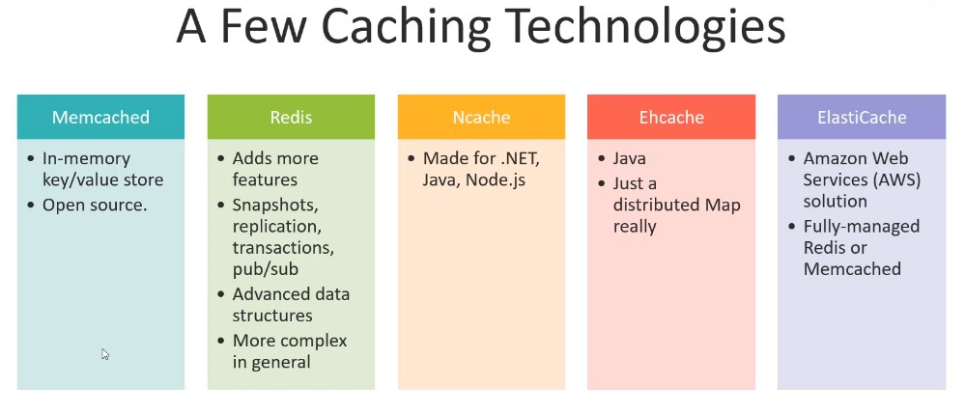
Memcached
- Simple key-value mapping in memory
Redis
- Snapshots, replication
- activites by public, and subscribers
- supports complex data structures
Elasticache
- AWS Cache service

Content Delivery Network
- Having edge servers near to the users to deliver frequently accessible static files.
  - CDNs – have caches at the edge to deliver it quickly.
    - Cache – everything the CDN stores is static, stored in key-value pairs
      - Eg: a request has been raised by a user, the main server responds the requested data[dynamic], CDN maps the request[key] with the data[value] sent by server <-> That’s a cache – a static content
      - Again CDN sends the same data to the same request by another user from the same edge location.
    - Cache configuration – Caches can be further configured to reuse template (use the template alone) sent by main server and impart images/videos/other content from that edge memory.
      - Tools used for configuration – Client-side rendering
        - Edge Side Includes (ESI) or edge compute to inject fragments (like product listings) into the template.

  - Case 1: the home page delivered to user before logging in is a static file. After logging in personalization happens then based on request if it’s already avialable in cache that’ll be sent or else will be sent from main server and caches that data.
  - Case 2: Why not cart data be stored in CDN
    - Cart is user specific – not having frequent/high no. of accesses – the main purpose of CDN [caching frequent access data] is failed here.
    - Cart | live stocks – has to be updated based on the trend(value change, availability change)
    - Writing in cart – has to propogate to main server and all the edges – high complexity, consistency fails.

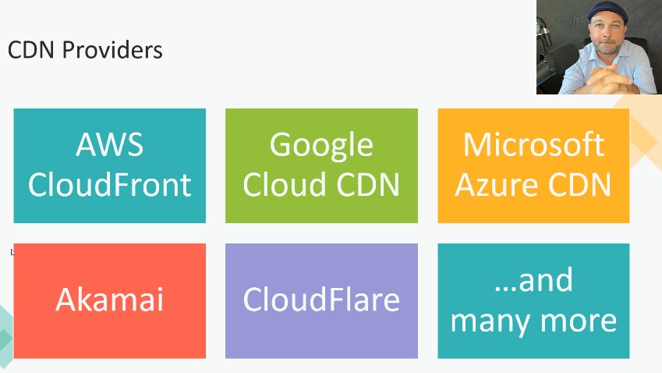
CDN Providers
- To use CDN provider of AWS/Azure/Google we don’t need to mount our entire application in the respective CSP.

Resiliency
- Distributing servers across data racks, data centers, regions to tolerate any downtime/loss.

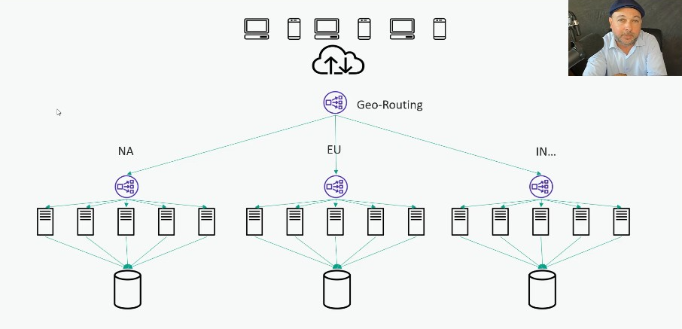
Geo- routing
- Placing a Geo-routing load distributor, forwarding requests based on the region.
- on region failures, it will forward the request to other regions.

--- Scaling of data---

Distributed Storage solutions
- Distributing data across data racks, data centers, regions to tolerate any downtime/loss.

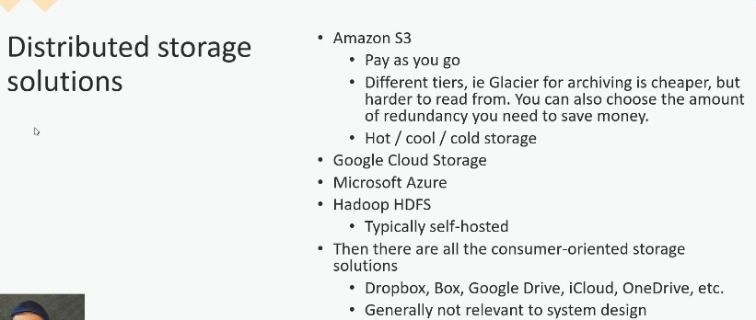

- Open Source: HDFS from Hadoop
  - Can be used to host servers by ourself.

Distributed Storage system – Working
- Main node = Name node; routing the requests to data’s place
  - Saves the data & server[where data’s been processed] in the same data node.
- Metadata – details of where the data’s stored.
- Distributed replication - Metadata, name node, data node – everything have a distributed replication.
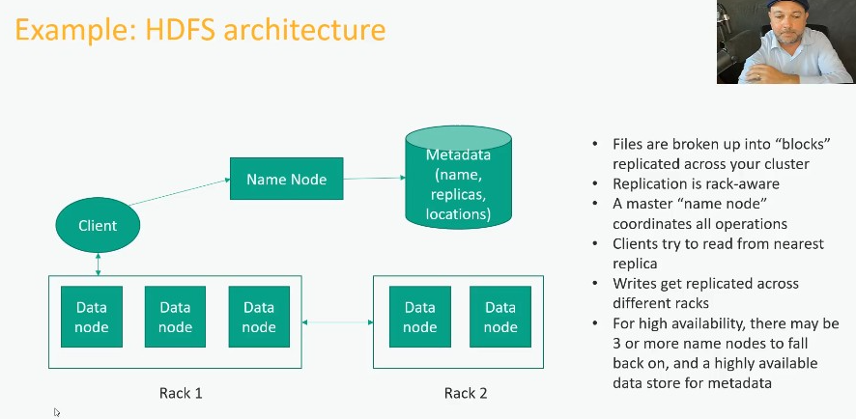

Data Structures
O Notation
- What’s the order of doing something(inserting/accessing/deleting..)

- Singly linked list – to implement stacks & queues
- Doubly linked list – to implement double ended queues
- Binary tree
  - Binary search tree – right, middle and left nodes will be in order.

Information retrieval
(old algorithms used in search engine)
TF-IDF = Term frequency/ Document frequency -> Gives the relevance of a specific word to a document useful in search engines.
- Term frequency – how frequently a term appears in a document
- Document frequency - how often a term appears in all the documents

Page Rank
- Prioritizing a page by the backlinks/Inbound links

- In Trend elasticache is used for search engines & Deep search is used for search in google search.

Major concepts in System design

Scaling
Scaling: More no. of users – need more serving capacity.

Scaling Servers
- When we receive more requests, we scale servers(vertical & horizontal scaling)
  - Requests are forwarded properly who Load Balancer
  - Reverse-Proxy can also acts as load balancer

Scaling DB
DB scaling will be dependent on read and write behaviour

Read
Indexing is the best for read effective operations
Next to indexing we’ll use DB replication:
- Primary DB is replicated to many Read replicas(Sec DBs) | also improves high availability - when primary DB fails sec DBs takeover
  - Primary DB- takes care of write operations
  - Read replicas – takes care of read requests

Write
Sharding is best for write efficient operations – The DB will be splitted row wise | Sharding aka Horizontal partitioning
Each DB server contains a subset of DB
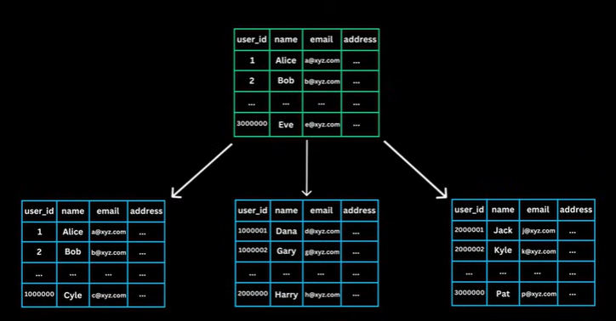
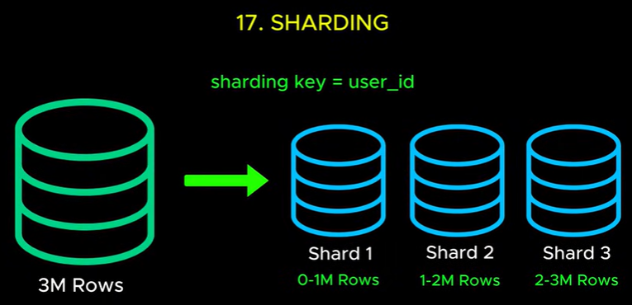
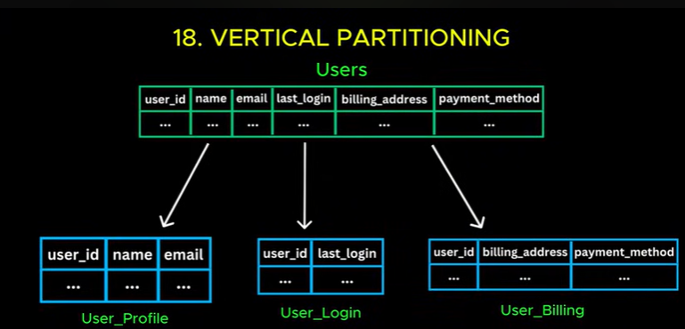
When servers struggles with the no. of cols:
Vertical Partitioning

To improve the DB access as better as possible instead of directly accessing the data from DB disk, we’re accessing the data from memory – Caching

Denormalization:
For read heavy operations in SQL
- Instead of using joins for getting data from 2 tables(joints delays the operation)
- Denormalization – creates a new table combining the tables -> avoid latency caused by joints.
Drawback: leads to increased storage makes the update complex

Storage
For storing the images, videos and other things – effective solution: Object storage (S3)
From there we come to CDN

Real time Communication
To access the lively updating data from server, the client has to repeatedly sends request(=polling) to server though there’s no update in the server -> which is waste of time
Resolution:

Web Sockets
Web sockets makes a connection through Handshake and keeps the connection open bw client and server, so when there’s an update/request in the server, that will be sent to client without a request so as the client.
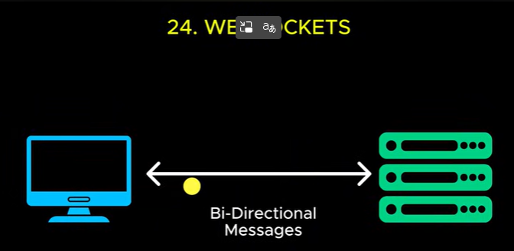

Web sockets works between client and server. Between server and server – we have

Web Hooks
- Receiver registers the provider with a web hook URL, so when provider has an update, it updates the receiver without any request.
- What’s the need for server-server communication ?
  - Eg: when a payment gateway wants to let the application know, that a payment has been done.
  - 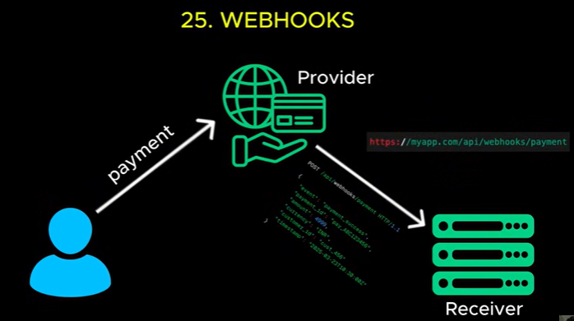

MicroServices
- Each microService handles one service with it’s own DB. Easy to scale and change in one service won’t affect the entire system

Communication among multiple MicroServices
- API isn’t efficient way so,
- we have the message queues

Message Queues
- promotes Async communication
- the messages queue contains the request/communication sent by one service, which can be retrieved by the respective service async.

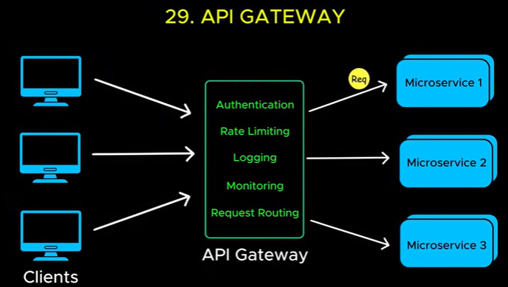
The communication among the microservices can be well handled by Message queues, but what about the requests/communications from public to the microservices?
That’s where we have API Gateway

API Gateway

Rate Limiting
done by API gateway
- limits over access(high no. of requests) by a single user

